**Table of Contents**

|  |  |  |
| --- | --- | --- |
| **Chapter No.** | **Description** | **Page No.** |
| Chapter 1 | Introduction | **4-6** |
| Chapter 2 | Literature Survey | **7-8** |
| Chapter 3 | Methodology | **9-12** |
| Chapter 4 | Result and Discussion | **13-14** |
| Chapter 5 | Conclusion and Future Work | **15** |
|  | References | **16** |

**Chapter 1**

**Introduction**

* 1. **Introduction**

Agriculture is often regarded as the backbone of any nation, playing a crucial role in sustaining the economy and ensuring food security. As the global population continues to rise, the demand for food increases, putting additional pressure on agricultural systems to enhance productivity and efficiency. Concurrently, the agricultural revolution is evolving alongside technological advancements, particularly with the integration of machine learning and artificial intelligence. Crops, being fundamental to our survival, face numerous challenges, among which crop diseases are a primary concern. These diseases can devastate crop yields, leading to significant economic losses and threatening food security.

Traditional methods of crop disease detection rely heavily on visual inspection by agricultural experts, a process that is time-consuming, labor-intensive, and often prone to human error. In many developing regions, such as rural areas of Bangladesh and India, farmers lack easy access to agricultural specialists and rely on their own experience to identify diseases. This practice can lead to incorrect diagnoses and delayed treatments, exacerbating the damage caused by crop diseases.

In recent years, there has been a growing interest in leveraging technology to address these challenges. Machine learning, particularly deep learning, has shown great promise in developing efficient and accurate systems for disease detection. Deep learning models, such as Convolutional Neural Networks (CNNs), have the capability to analyze complex patterns in images, making them ideal for identifying disease symptoms in plant leaves. By utilizing these advanced techniques, we can revolutionize the way crop diseases are detected, providing timely and precise diagnoses that can help mitigate crop losses and improve food security.

* 1. **Problem Definition**

Crop diseases represent a formidable challenge in agriculture, significantly impacting crop yield and quality. The traditional approach to disease detection, which involves visual inspections by trained agronomists, is fraught with several limitations. These methods are not only labor-intensive and time-consuming but also limited by the availability and expertise of specialists. In many rural and remote areas, farmers do not have ready access to such expertise, often leading to delayed or incorrect diagnoses and subsequent treatments. This reliance on manual inspection is inefficient and cannot scale to meet the demands of modern agriculture, especially in regions with large-scale farming operations.

The variability in disease symptoms, which can be subtle and complex, further complicates the detection process. Factors such as environmental conditions, crop variety, and growth stages can affect the manifestation of disease symptoms, making it difficult to achieve consistent and accurate diagnoses through traditional methods.

Advances in machine learning and deep learning offer a promising solution to this problem. By leveraging large datasets of plant images and training sophisticated neural network models, it is possible to develop automated systems that can accurately identify diseases from images of plant leaves. These systems can provide rapid diagnoses, reducing the time and effort required for disease detection and enabling timely intervention to prevent widespread crop damage.

* 1. **Objectives**

The primary objective of this project is to develop an efficient, accurate, and scalable system for detecting crop diseases using machine learning, particularly deep learning techniques. The project aims to address the limitations of traditional disease detection methods and provide a modern solution that can be readily adopted by farmers and agricultural professionals. The specific objectives are as follows:

1. **Develop a Robust Dataset**: Compile a comprehensive dataset of crop images, including healthy and diseased plants. This dataset will cover various stages of crop growth and different environmental conditions to ensure the model's robustness and generalizability.
2. **Preprocess Data**: Implement preprocessing techniques to enhance the quality of the images and standardize the data. This includes image enhancement, normalization, and augmentation to increase the dataset's diversity and improve the model's performance.
3. **Model Selection and Training**: Evaluate and select the most effective deep learning algorithms for crop disease detection. Convolutional Neural Networks (CNNs), such as VGG-16, VGG-19, and ResNet-50, will be considered for their proven ability to handle image classification tasks. The models will be trained using the prepared dataset to learn to identify disease symptoms accurately.
4. **Model Evaluation**: Assess the performance of the trained models using metrics such as accuracy, precision, recall, and F1-score. The goal is to ensure high reliability and effectiveness in real-world applications.
   1. **Scope of this project**

The scope of this project encompasses several key areas to ensure a comprehensive and impactful solution for crop disease detection:

* **Crop Types**: The initial focus will be on high-value crops that are particularly susceptible to diseases, such as tomatoes, potatoes, and peppers. These crops are chosen due to their economic importance and the significant impact of diseases on their yield and quality.
* **Disease Types**: The project will aim to identify and diagnose a wide range of common diseases affecting the selected crops. This includes bacterial, viral, and fungal infections, which are prevalent and pose major threats to crop health.
* **Geographical Focus**: While the model will be designed to be globally applicable, the initial data collection and testing will focus on regions with significant agricultural activity. This includes both developed and developing countries, with particular attention to areas where traditional disease detection methods are inadequate.
* **Technological Integration**: The project will leverage state-of-the-art machine learning frameworks and cloud computing resources to ensure scalability and efficiency. This includes using pre-trained models, transfer learning, and advanced image processing techniques to enhance the detection system.

By addressing these areas, the project aims to create a transformative tool that can significantly enhance the efficiency and accuracy of crop disease detection, ultimately contributing to higher agricultural productivity and sustainability.

**Chapter 2**

**Literature Survey**

* 1. **Related Work**
     1. **Shape- and Texture-Based Identification**

In [1], the authors identified diseases using tomato-leaf images. They used different geometric and histogram-based features from segmented diseased portions and applied an SVM classifier with different kernels for classification. In [2], P. Babu et al. used a feed-forward neural network and backpropagation to identify plant leaves and their diseases. S. S. Chouhan et al. [3] used a bacterial-foraging-optimization-based radial-basis function neural network (BRBFNN) for the identification of leaves and fungal diseases in plants. They employed a region-growing algorithm to extract features from a leaf based on seed points with similar attributes. The bacterial-foraging optimization technique is used to speed up the network and improve classification accuracy.

* + 1. **Deep- Learning-Based Identification**

Ferentinos et al. [4] used various CNN architectures to identify 58 different plant diseases, achieving high classification accuracy and testing the CNN architecture with real-time images. Sladojevic et al. [5] designed a deep learning architecture to identify 13 different plant diseases using the Caffe DL framework. In [6], the authors proposed a nine-layer CNN model to identify plant diseases, using the PlantVillage dataset and data-augmentation techniques to increase data size and analyze performance, reporting better accuracy than traditional machine-learning-based approaches.

KR Aravind et al. [7] used six different pre-trained networks (AlexNet, VGG16, VGG19, GoogLeNet, ResNet101, and DenseNet201) to identify 10 different plant diseases, achieving the highest accuracy rate of 97.3% using GoogleNet. Ghazi et al. [8] used a transfer-learning-based approach on pretrained deep-learning models to improve the accuracy of plant disease identification. In [9], the authors used a shallow CNN with SVM and RF classifiers to classify three different types of plant diseases, showing that classification using SVM and RF classifiers with features extracted from the shallow CNN outperformed pretrained deep learning models.

Oyewola et al. [10] identified five different cassava-plant diseases using plain convolutional neural network (PCNN) and deep residual network (DRNN), finding that DRNN outperformed PCNN by a margin of 9.25%. A VGG16, ResNet, and DenseNet model was used by Yafeng Zhao et al. [11] to identify plant diseases from the PlantVillage dataset, employing a double generative adversarial network (DoubleGAN) for data augmentation, which improved the performance results.

Since the release of LeNet (1988), CNN architectures have evolved dramatically, incorporating features like ReLU nonlinearity and overlapping pooling, which have reduced training time and error rate. ResNet introduced dynamic skip connections and heavy batch normalization, allowing training at higher learning rates. Comparative studies have shown ResNet producing superior results in classifying grape leaf diseases compared to VGGNet, GoogLeNet, and DenseNet. Techniques such as data pre-processing and augmentation are crucial for model performance, with RGB data preferred for clear, noise-free images. Transfer learning has also been highly successful, especially when fine-tuning pre-trained models on databases like ImageNet. The quality and type of training data, including in-field imagery, significantly impact a model’s capabilities and reliability.

**Chapter 3**

**Methodology**

* 1. **Methodology used**

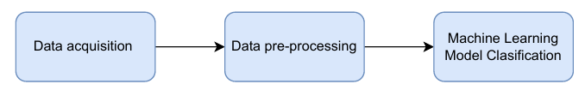

**Fig1. Working procedure of proposed mode**

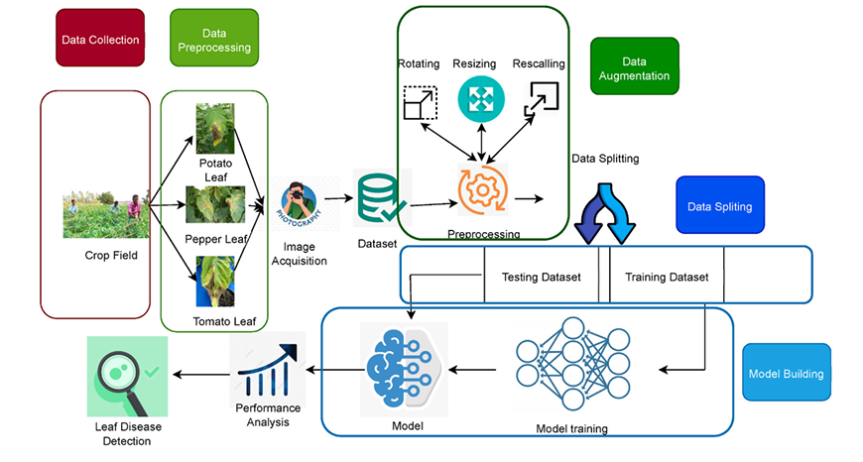

**Fig2. Proposed workflow diagram**

* 1. **Technologies used**

**3.2.1 CNN**

Convolutional Neural Networks (CNNs) are a class of deep learning models particularly adept at image recognition tasks. They utilize a layered structure, comprising convolutional layers, pooling layers, and fully connected layers. Convolutional layers apply filters to input images, detecting features such as edges, textures, and patterns. Pooling layers then reduce the dimensionality, enabling the network to handle larger images efficiently while preserving essential features. The fully connected layers at the end aggregate these features for final classification. Key innovations in CNNs include the use of ReLU activations for non-linearity and dropout for regularization to prevent overfitting. CNNs have revolutionized fields such as computer vision, medical imaging, and autonomous driving by enabling machines to interpret and analyze visual data with high accuracy. Their ability to learn hierarchical representations from raw pixel data has made them the backbone of modern image and video recognition systems.

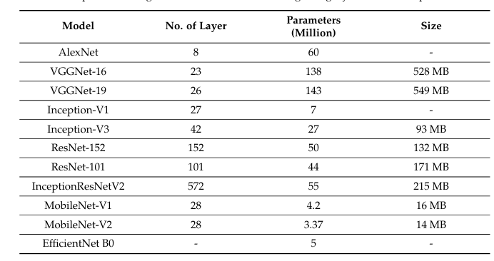

**Table1. Comparison among different CNN architectures regarding layer number and parameter sixe**

**3.2.2 VGGNet-16**

VGGNet-16 has 16 convolutional layers and a uniform design, considered one of the most extensively utilized structures for disease detection in image classification. The primary accomplish ment of VGG-16 is demonstrating that, in some circumstances, growing network intensity can improve system performance. Convolution, fully connected and pooling layers are three compo nents of the VGG-16 transfer learning algorithm. The convolution layer applies filters to pictures to extract information; its two most important properties are the kernel and stride size. The poling layer minimizes the network’s spatial size and associated calculations.

**3.2.3 VGGNet-19**

The CNN VGG-19 transfer learning model was first presented. It contains 3 dense layers, 16 convolutional layers, and 19 layers to categorize images into 1000 categories. The model is composed of 3 fully connected (FC) layers, 2 Conv 1 max pools, 4 Conv 1 max pool, 4 Conv 1 max pools, and 2 Conv 1 max pools. It is a very popular photo prediction model since each ConvNet uses a lot of 3 ×3 filters.

**3.2.4 Inception V3**

It's a simple model with little bias that may be used to create a classifier model, with the root node being the first to be considered in a top-down approach. It is a well-known machine learning model. A decision tree is referred to as a tuple recursive classifier. It is a potent approach for data mining and a powerful method of multi-variable analysis. This approach depicts the variables involved in accomplishing a particular goal, as well as the motivations for obtaining the goal.

**3.2.5 AlexNet**

AlexNet, introduced by Alex Krizhevsky et al. in 2012, marked a significant milestone in the field of deep learning and computer vision. AlexNet consists of five convolutional layers, some followed by max-pooling layers, and three fully connected layers. Key features include the use of ReLU activations to introduce non-linearity, which accelerates training, and dropout layers to mitigate overfitting by randomly omitting neurons during training. Additionally, AlexNet leveraged GPU acceleration to handle the computational demands of training deep networks on large datasets. This architecture’s success demonstrated the effectiveness of deep learning for image classification tasks, paving the way for more complex models like VGGNet, GoogLeNet, and ResNet, and establishing CNNs as a standard approach in computer vision research and applications.

**3.2.6 ResNet50**

The ResNet50 model is a subset of the ResNet family and 48 Convolutional layers, 1 MaxPool layer, and 1 Average Pool layer make up this structure. This is a popular ResNet model for image classification. The ResNet50 design is divided into four primary phases. The first convolution stage consists of three layers: a 1*1, 64 kernel, a 3*3, 64 kernel, and lastly a 1*1,256 kernel. These three layers have now undergone three replications, for a total of nine layers. Next, a 1*1,128 kernel is observed, followed by a 3*3,128 kernel and finally a 1*1,512 kernel. This method was used four times for a total of 12 layers. The next kernel is 1*1,256, and then there are two more kernels with 3*3,256 and 1*1, 1024; this is repeated six times to give a total of eighteen layers. After that, two further kernels of 3*3,512 and 1*1, 2048 were built, followed by a 1*1,512 kernel. Using this procedure three times gave us nine layers in total. The graphical depiction of the ResNet50 architecture is shown in Fig. 3.

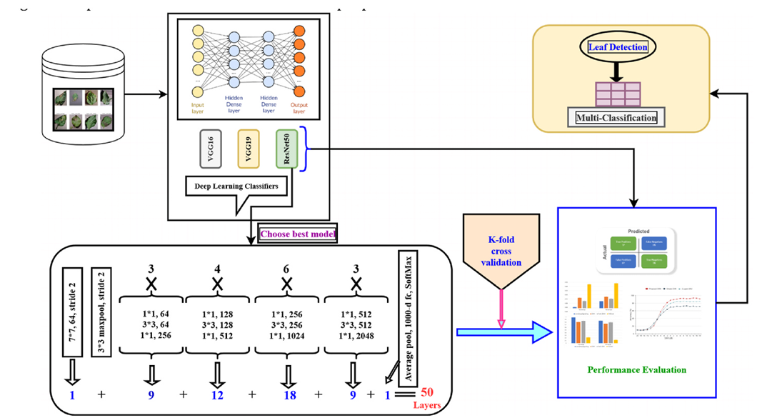

**Fig3. ResNet50 Model Workflow diagram**

**Chapter 4**

**Result and Discussion**

**4.1 Results**

For any deep learning algorithm, learning curves represent the learning capabilities during the training concerning the dataset in an incremental fashion. The training accuracy effectively reflects how well the model is learning from the training dataset as the number of epochs increases. However, based on a hold-out validation dataset, the validation accuracy predicts the model's generalizability. Although there was little volatility during the validation test, the loss curve shows that the training and validation losses dropped over time and that the interval between them was short over the experiments. The training and validation accuracy and loss for the proposal are displayed in Fig. 4.1. The training and validation accuracy curves in Figure 4 indicate that, despite some variation in the validation curve, accuracy performance increases with training time. Conversely, the loss graph shows good fitting as

On the other hand, the loss graph shows good fitting because there is very little change between the training and validation loss curves.

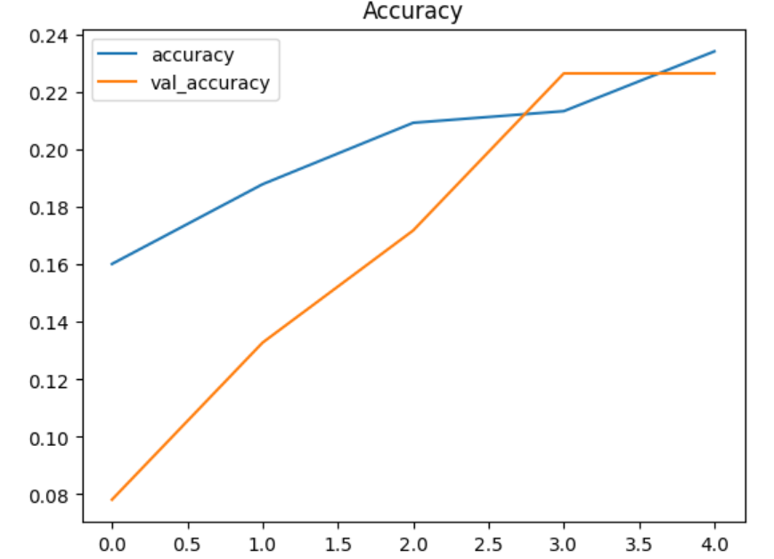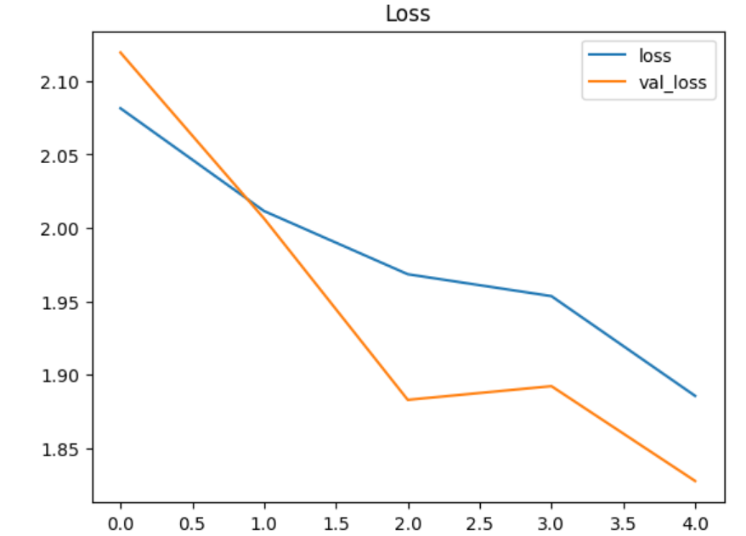

**Fig 4.1 Accuracy Results**

**4.2 Discussion**

In this research, several deep transfer learning models for crop leaf detection have been proposed. The suggested method for identifying multi-crop leaves is tested on large data sets. In order to effectively classify leaf diseases, we examine the performance of three well-known transfer learning models: VGG-16, VGG-19, and ResNet50. Our results show that ResNet50 performs better than the other two models. Two of the most widely used models for classifying images are the traditional VGG-16 and VGG-19, which have 16 and 19 layers, respectively. However, neither model is able to overcome the difficulty of vanishing gradients, and as a result, the accuracy levels produced fall short of what is considered acceptable. On the other hand, ResNet50 effectively tackles this issue and considerably lowers testing errors in simulation settings. As such, this model demonstrates improved performance capabilities over the previously listed models. Using a technique based on CNN, they conducted studies on apple and multi-crop leaves, respectively. Their dataset was small, despite the fact that their accuracy was generally acceptable. In that instance, our suggested model outperformed theirs with an accuracy of 98.60% when it was applied to a sizable dataset using a CNN-based methodology. Table 4.1 offers a number of deep learning techniques for crop leaf identification, although their experiments were limited to a single object (citrus, apple, and potato leaves, respectively). Furthermore, the dataset for this work was small, as was the classification category.

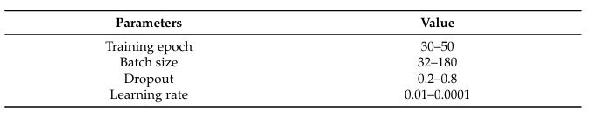

**Table 4.1 Parameters used in CNN for training**

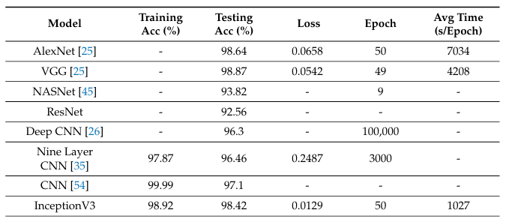

**Table 4.2 Performance comparison of different DL architectures**

**Chapter 5**

**Conclusion**

In this study, a pre-trained Convolutional Neural Network (CNN) was optimized and made available online in this study to help smallholder farmers diagnose crop illnesses precisely. In controlled situations, the InceptionV3 model yielded the highest accuracy, at 97.2%. The type, stage, and background data of the disease, as well as the makeup of the objects, all affect its accuracy. User instructions are required to guarantee commercial applicability, with a focus on the requirement for simple backdrops and single leaf images that resemble the training data. Although the model's generalizability was increased by augmentation and transfer learning, its accuracy decreased to 44% when tested using in-field photos. This emphasizes how important it is to diversity training datasets by adding more plant anatomy, a range of backgrounds, and a range of disease stages. The study shows how CNNs can help smallholder farmers, but it also emphasizes the need for more work to improve efficacy by diversifying datasets and testing online applications in practical settings.

**Future Work**

Future research in machine learning for crop disease detection should concentrate on a few important areas. Diversifying training datasets is paramount, incorporating images with varied backgrounds, multiple plant anatomies, and different disease stages to enhance model robustness and accuracy in real-world scenarios. Developing more advanced data augmentation strategies can further aid in generalizing models to varied conditions. Furthermore, combining hyper-spectral and multi-spectral imaging data can yield richer data for more accurate. Advanced machine learning models, such as ensemble approaches and hybrid approaches that combine CNNs with additional methods like transformers or attention processes, should also be investigated in research. In order to improve models based on real-world input, real-time deployment and validation in the field are essential. This calls for cooperation with agricultural specialists. Last but not least, developing mobile applications that are easy to use and work well in a variety of environmental settings would empower farmers all over the world and guarantee prompt and precise crop disease detection and prevention. Continuous improvement and accessibility of the diagnostic tools can also be facilitated by implementing cloud-based systems for data storage and model upgrades.

**References**

**[1]** Mokhtar, U.; Ali, M.A.; Hassanien, A.E.; Hefny, H. Identifying two of tomatoes leaf viruses

using support vector machine. In Information Systems Design and Intelligent Applications; Springer

Berlin/Heidelberg, Germany, 2015; pp. 771–782. **(Example: Research papers)**

**[2]** Babu, M.P.; Rao, B.S. Leaves Recognition Using Back Propagation Neural Network-Advice for

Pest and Disease Control on Crops. Available online :

https://citeseerx.ist.psu.edu/viewdoc/download?doi=10.1.1.110.3632&rep=rep1&type=pdf (accessed on 1 May2021). **(Example: Research papers)**

**[3]** Chouhan,S.S.; Kaul, A.; Singh, U.P.; Jain, S. Bacterial foraging optimization based radial basis function neural network (BRBFNN) for identification and classification of plant leaf diseases: An automatic approach towards plant pathology. IEEE Access 2018, 6, 8852–8863. [CrossRef]

**(Example : Journals)**

**[4]** Ferentinos, K.P. Deep learning models for plant disease detection and diagnosis. Comput.

Electron. Agric. 2018, 145, 311–318. [CrossRef] **(Example: Research papers)**

**[5]** Sladojevic, S.; Arsenovic, M.; Anderla, A.; Culibrk, D.; Stefanovic, D. Deep neural networks based recognition of plant diseases by leaf image classification. Comput. Intell. Neurosci. 2016, 2016, 1–10. [CrossRef] [PubMed] **(Example: Research papers)**

**[6]** Geetharamani, G.; Pandian, A. Identification of plant leaf diseases using a nine-layer deep convolutional neural network. Comput. Electr. Eng. 2019, 76, 323–338.**(Example: Research papers)**

**[7]** Rangarajan Aravind, K.; Raja, P. Automated disease classification in (Selected) agricultural crops using transfer learning. Autom. ˇ Casopis Autom. Mjer. Elektron. Raˇcunarstvo Komun. 2020, 61, 260–272. [CrossRef] **(Example: Research papers)**

**[8]** Ghazi, M.M.; Yanikoglu, B.; Aptoula, E. Plant identification using deep neural networks via optimization of transfer learning parameters. Neurocomputing 2017, 235, 228–235. [CrossRef]

**[9]** Li, Y.; Nie, J.; Chao, X. Do we really need deep CNN for plant diseases identification? Comput. Electron. Agric. 2020, 178, 105803. [CrossRef] **(Example: Research papers)**

**[10]** Oyewola, D.O.; Dada, E.G.; Misra, S.; Damaševiˇcius, R. Detecting cassava mosaic disease using a deep residual convolutional neural network with distinct block processing. PeerJ Comput. Sci. 2021, 7, e352. [CrossRef] [PubMed] **(Example: Research papers)**

**[11]** Zhao, Y.; Chen, Z.; Gao, X.; Song, W.; Xiong, Q.; Hu, J.; Zhang, Z. Plant Disease Detection using Generated Leaves Based on DoubleGAN. IEEE/ACM Trans. Comput. Biol. Bioinform. 2021. [CrossRef] [PubMed] **(Example: Research papers)**